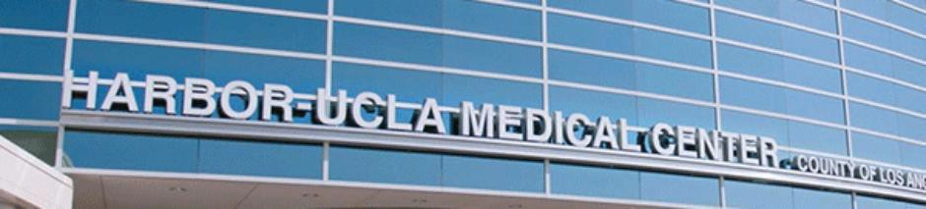

**Community Treatment/Trauma**

[**Dorit**](http://www.harboruclapsychology.org/our-training-faculty-and-staff/lisa-bolden-psy-d/) **Saberi, Ph.D.**, ***Track Supervisor***

The Community Treatment/Trauma track is intended to equip practicum students with the skills, knowledge, and experience in providing clinical care in community-based treatment and to develop knowledge in assessment, treatment planning, evidence-based therapeutic modalities, and crisis response for clients/consumers diagnosed with chronic mental illness, who are high utilizers of psychiatric emergency and inpatient services, and to adults who are survivors of trauma. Emphasis is also placed on serving individuals with a recent history of justice system involvement.

Community Treatment

The track’s focus on community treatment emphasizes the importance of a multidisciplinary treatment team serving as the single fixed point of responsibility for clients/consumers. The multidisciplinary treatment team attends not only to psychiatric systems, but also helps clients/members meet their needs in physical health, dental, co-morbid substance abuse, housing, financial, educational, work, social, recreational, and legal needs, among others. This approach to community-based treatment and service provision enhances continuity of care and helps ensure that clinical decision-making always has the benefit of relatively complete and up-to-date information for the client/consumer. Students in this track serve as part of the multidisciplinary team and are mainly responsible for providing assessment, treatment planning, individual and group therapy, and crisis services to clients/consumers and their family members.

Trauma

Students receive advanced training in Cognitive Behavior Therapy (CBT), Dialectical Behavior Therapy (DBT) for borderline personality disorder and Prolonged Exposure (PE) for PTSD. They will also receive training in Trauma Informed Care and use Cognitive Processing Therapy (CPT), Community Resiliency Model (CRM) for trauma-informed and trauma specific services, and Motivational Interviewing to enhance treatment collaboration. In addition, students may have the option of being involved in collaborating in teaching evidence-based treatment to other service providers in the Department of Mental Health.

Community Treatment/Trauma Track Preferred Experience

· Prior experience in the assessment and treatment of persons with severe and persistent mental illness and experience with Trauma Informed Care/Trauma Specific Services preferred

· Previous experience conducting group and individual CBT and DBT.

Community Treatment/Trauma Emphasis Area Required Clinical Experience

· Serve as primary therapist. The role of therapist involves providing CBT, DBT and PE to 5-6 Community Treatment/Trauma clients.

· Participate in Dialectic Behavior Therapy program, which includes: DBT Extended Track (for co-morbid cognitive deficits) skills group co-leader, DBT skills group for friends and family, individual therapist for 1-2 cases, weekly team consultation meetings, possible trainings and consultations in DBT for Department of Mental Health clinicians in other agencies.

· Participate in Cognitive Behavior Therapy Program (individual therapist for 2-3 cases, attend weekly CBT class, weekly CBT seminar and weekly adult trauma seminar)

· Participate in providing Trauma Informed/Trauma Specific services to 2-3 Trauma clients.

· Participate as a member of a multidisciplinary team.

Community Treatment/Trauma Track Required Training and Courses·

Cognitive Behavior Therapy Seminar (1.5 hours/week)

· CBT Group Supervision Course (1 hour per week)

· Three day DBT training (24 hours)

· Two day Prolonged-Exposure training (16 hours)

· One day ACT training (8 hours)

· DBT Team meeting for Assertive Community Treatment Team (1.5 hours per week)

· Adult Trauma Seminar (1 hour per week)

Community Treatment/Trauma Emphasis Area Required LAC DMH Clinical Experience

Students in the Community Treatment/Trauma emphasis area will receive training in larger systems-focused services, including the following:

· Assessment of treatment needs for justice involved individuals.

· Delivery of trauma treatment or other evidenced-based treatments (CBT, DBT) to justice involved individuals.

Additionally, other system-focused training opportunities may develop over the course of the practicum year based on the needs of the clinical populations served and the public mental health system.

Community Treatment/Trauma Emphasis Area Elective Courses/Clinical Experiences

· Students may also provide psychoeducational groups for AMI/ABLE, time-limited problem-specific psychotherapy, psychological assessments and other electives in the Division.

· Students may provide psychoeducational groups and DBT informed behavioral plans to patients served on the psychiatry inpatient units at Harbor-UCLA.

· Students may collaborate in providing CBT, DBT, and Prolonged Exposure for PTSD training to LAC DMH employees.

· Students may collaborate in providing DBT training modified for the jail setting to DMH staff working for the DMH Adult Justice, Housing, Education, and Employment Services Bureau.

February 2022